MasterShaper
Easy QoS Traffic Shaping

Documentation

http://www.mastershaper.org

Version 0.4x

Directory
1 Introduction 4
1.1 MasterShaper 4
1.2 Requirements 4
1.3 IMQ-Devices – What for? 5
1.4 Classifiers & Queuing Disciplines 6
1.5 Support, Ideas & Improvements 8
2 Usage 9
2.1 Definitions & Terms 9
2.1.1 Bandwidth 9
2.1.2 Protocols 9
2.1.3 Ports 9
2.1.4 Targets 9
2.1.5 Service Levels 10
2.1.6 Filters 10
2.1.6.1 layer7 Protocol matching 10
2.1.7 Chains 11
2.1.8 Pipes 11
2.1.9 Bridge or Router 12
2.2 Installation 13
2.2.1 Package 13
2.2.2 Procedure 13
2.2.3 Security 17
2.3 Statistic collector tc_collector.pl 18
2.4 Configuration 19
2.4.1 Settings 19
2.4.1.1 Options 19
2.4.1.2 Users 20
2.4.1.3 Targets 21
2.4.2 Manage 21
2.4.2.1 Service Levels 21
2.4.2.2 Filters 21
2.4.2.3 Chains 22
2.4.2.4 Pipes 22
2.4.3 Monitoring 23
2.4.3.1 Chains, Pipes and Bandwidth 23
2.4.4 Overview 24
2.4.5 Rules 24
2.4.5.1 Load 24
2.4.5.2 Load (debug) 25
2.4.5.3 Show 25
2.4.5.4 Unload 25
2.4.6 shaper_loader.sh 25
2.5 Tools 26
2.5.1 Runlevel-Init-Script 26
2.6 Shaping Examples 27
2.6.1 Shaping on a Web-Server 27
2.6.1.1 Guidelines 27
2.6.1.2 Implementation 27
2.6.2 Shaping on a gateway 28
2.6.2.1 Guidelines 28
2.6.2.2 Implementation 28
2.6.3 Shaping per department 29
2.6.3.1 Guidelines 29
2.6.3.2 Implementation 29
3 License 30

Introduction

MasterShaper

The MasterShaper is a web interface for Linux network traffic utilities. It provides an “easy2use” web interface around the Quality of Service (QoS) functions available in the Linux 2.4 & 2.6 kernel series. Users can define their own rulesets for handling network flow and also get feedback through graphical statistics about current bandwidth usage and shaping situation.

Mastershaper's goal is to make traffic shaping possible for users who know about networking and the traffic shaping capabilities, but have not much experience with Linux, scripting and other tools needed to do this job.

In the end, the shaping features should be comparable with commercial shaping products like Allot's Netenforcer (http://www.allot.com/html/products_netenforcer.shtm) or Packeteers shaper (http://www.packeteer.com/).

Currently it's only a shaper utility. It's doesn't include a network traffic analyser like the commercial products. It will not display what's going on your network. It will only display the things happens according your ruleset.

MasterShaper can be used on a single machine, router or on a transparent bridge.

Requirements

- Linux kernel version 2.4 or 2.6.x (http://www.kernel.org)
- iproute2 which contains the tc command (http://developer.osdl.org/dev/iproute2/)
- IMQ-Devices (If you want to shape inbound traffic, http://www.linuximq.net)
- Web-Server with PHP support (Apache2, mod_php4, http://httpd.apache.org)
- PHP4 with JPEG, libgd and MySQL support (not tested yet with PHP5, http://www.php.net)
- MySQL database (MySQL 4.1 or MySQL 5.0, http://www.mysql.com)
- PHP pear modules DB & Net_IPv4
- Perl5 with DBD interface (DBI-MySQL)
- phplayersmenu (sourceforge project, http://phplayersmenu.sourceforge.net)
- jpgraph (http://www.aditus.nu/jpgraph/)
- Web-Browser (with DHTML- and JavaScript-Support, http://www.mozilla.org/products/firefox/)
- sudo

Be aware that the functionality MasterShaper represents is dependent on the availability of features on your system. Some features of the 2.6.x kernels are not back-ported to 2.4.x kernels and so can't be used under 2.4. Also if you have outdated versions of iptables or iproute2 you will discover problems with some features. Before report problems check if newer versions are available and upgrade first.

IMQ-Devices – What for?

Primarily tc-utilities are arranged for outbound traffic (egress). With outbound traffic you have a lot of options to shape your network traffic. The built-in ingress functions are not so powerful and rudimentary – so you have much less possibilities to control your incoming traffic.

The problem on ingress shaping is, that traffic which arrives on your network card interface, is already on the line and consumes bandwidth. You only have the possibility to drop fast incoming packets or delaying sending acknowledge (ACK) packets and hope that the sender will slow down sending rate (most IP stacks act in this way).

However - in this case you are sitting on the wrong side of the network flow and ingress shaping is less effective then egress shaping. Whatever a supplier of commercial shaping products is telling you - they have all the same problem like the solutions with Linux QoS utilities. The ideal solution is to shape on both sides.

Meanwhile IMQ-Devices – Intermediate Queueing Device http://www.linuximq.net - have been arranged to fit this needing. With iptables rules incoming & outgoing traffic will be forward to the queueing devices. The advantage of this - you can use “outgoing traffic rules” on ingress traffic.

To use the IMQ devices you have to patch your kernel and iptables. You will find enough howto's for this in the Internet (use google) – so it will not be explained here.

http://www.linuximq.net/faq.html
http://wiki.nix.hu/cgi-bin/twiki/view/IMQ/ImqFaq

If you want to use IMQ for your external interface (lets say it ppp0), then the IMQ usage can be enabled with:

ip link set imq0 up
ip link set imq1 up

iptables -t mangle -I PREROUTING -i ppp0 -j IMQ --to-dev 0
iptables -t mangle -I POSTROUTING -o ppp0 -j IMQ --to-dev 1

Now you can use the IMQ devices as incoming (ex. imq0) and outgoing (ex. imq1) device in the MasterShaper options.

Don't forget – For IMQ usage you have to patch kernel AND iptables! For your kernel you need the options CONFIG_IMQ AND CONFIG_IP_NF_TARGET_IMQ.

Be aware that you can NOT use Mastershaper's iptables-matching on IMQ devices! With IMQ device you can only use tc-filter. iptables isn't capable to match packets appearing on a IMQ device.

Classifiers & Queuing Disciplines

Since V0.30 MasterShaper supports three Classifiers (available in 2.6 kernel):

  - HTB (Hierarchical Token Bucket) http://luxik.cdi.cz/~devik/qos/htb/
  - HFSC (Hierarchical Fair Service Curve), http://www.cs.cmu.edu/~hzhang/HFSC/main.html
  - CBQ (Class Based Queueing), http://www.icir.org/floyd/cbq.html

HTB is capable of supporting a guaranteed minimum bandwidth for a traffic class. Furthermore it let you define the maximum bandwidth, which a class can lend from other classes, if the bandwidth is unused. You can define burst levels and priorization of HTB class. Priorization only affects how much unused bandwidth a class can lend from other classes – higher priorities will gain more bandwidth.

HFSC is capable of supporting a guaranteed maximum delay of network packets. This is important for real time applications like “Voice over IP” (VoIP), where delays & jitter have a bad impact on speech quality. Also with HFSC you can define a minimum guaranteed bandwidth for each class, and a maximum bandwidth which can be used by this class. A limitation of HFSC (doesn't update statistics of parent classes) makes it impossible to draw bandwidth & chain graphs. So only pipe graphs are working with HFSC.

CBQ exists much longer then HTB but has less powerful options for traffic control. MasterShaper support CBQ in case HTB is not available.

Vincent Perrier has made some tests HTB versus HFSC. Take a look on his homepage:
http://www.rawsoft.org/example_of_use.html

Mastershaper's default behaviour is HTB. You can change this in the MasterShaper web interface:

Settings " Options " Queuing Discipline

With V0.42 MasterShaper is able to use different Queuing Disciplines (before only SFQ was used). This Queuing Disciplines are used when packets leaving an interface to obtain an fairly distribution of bandwidth between traffic.

Currently supported are:

  - SFQ (Stochastic Fairness Queueing, in 2.6 kernel)
  - ESFQ (Enhanced Stochastic Fairness Queueing, http://fatooh.org/esfq-2.6/)
  - HFSC (Hierarchical Fair Service Curve, in 2.6 kernel)
  - NETEM (Network Emulator, in 2.6 kernel, http://linux-net.osdl.org/index.php/Netem

NETEM is capable of emulating “real network conditions” like delay, jitter, packet loss, duplication and reordering. MasterShaper is only acting is a GUI to enter the NETEM parameters. Remember that this can also affect your connection to the server which runs MasterShaper. NETEM needs support in kernel (CONFIG_NET_SCH_NETEM) and a newer version of iproute2 (http://linux-net.osdl.org/index.php/Iproute2) package to support every NETEM option.

All of these Classifiers & Queuing Disciplines have different appendages to do their job. If you want to know more about the theory of these schedulers, please refer to their documentations or home pages in the web. This would blow up this documentation, so only some features will be highlighted here.

Support, Ideas & Improvements

In case you have problems setting up MasterShaper take a look into the support forum on Mastershaper's homepage if your problems are already known – so please – use the SEARCH functionalities first before make a new post:

http://www.mastershaper.org

If you have ideas or other improvements proposals don't hesitate to post them into the “Feature Request & Inspirations” thread in the support forum.

Usage

Definitions & Terms

The MasterShaper uses some terms to define the shaping rules.

Bandwidth

Bandwidth mean the network speed of your link. MasterShaper always uses speed definitions in kbit per second (kbit/s).

Protocols

You often meet protocols in network environments. In our current time you will often meet IP-Traffic (TCP/UDP) or ICMP-Traffic (ping) – but there are many other protocols like ESP & AH for IPSec, GRE for GRE-Packet-Tunnelling or Router-Protocols like IGMP available.

Each protocol has a unique number which is assigned by IANA:
http://www.iana.org/assignments/protocol-numbers

Ports

Ports reflect the common port numbers for TCP- & UDP-traffic (HTTP/80, IMAP/143,...).

During installation you can instruct MasterShaper Installer to fill the ports table with all ports assigned by IANA:
http://www.iana.org/assignments/port-numbers

Targets

Targets means IP-Addresses or MAC-Addresses.

IP-Addresses can be specified as single host (1.1.1.1), network address (10.0.0.0/8) or ip-range (1.1.1.1-1.1.1.9).

Multiple targets can be grouped together as target groups.

Think about when you are able to match on MAC-Addresses! You only see MAC-Addresses in your local attached networked. You can't match on MAC-Addresses from machines which are behind routers or in other subnets. This is Ethernet design and has nothing to do with Linux or other system capabilities.

Service Levels

Service Levels mean predefined bandwidth limits.

Here you define detailed parameters for HTB, HFSC or CBQ classifiers. For CBQ you can specify rate and priority. In addition you can define ceil and burst with HTB for incoming and outgoing traffic (asymmetric lines). For HFSC it's possible to specify the maximum delay of network packets.

Here you also specify the Queuing Discipline which should be used. This parameter is only used for pipes. Service Levels which are assigned to Chains will ignore this setting.

Filters

Filters represent methods to match your traffic against defined rules. For example you can define, that a filter “Web-Traffic” match the HTTP- & HTTPS-ports 80/tcp & 443/tcp. Furthermore you can match on TOS-Flags, TCP-Flags, IPP2P, layer7, Time, packet length, ...

The availability of filter-functions depends on which matching-system you use. MasterShaper supports tc-filter and iptables. While tc-filter is fast and already integrated in the iproute2 package, iptables is a additional subsystem which supports many fancy match-methods. If you don't need the features iptables offers simply rely on tc-filter.

To find out, if your iptables installation supports all MasterShaper features, check out if the necessary match-modules are available in the iptables modules directory (usually /lib/iptables)

*) libipt_TOS.so for TOS matching
*) libipt_tcp.so for TCP-Flag matching
*) libipt_ipp2p.so for IP-P2P matching (http://www.ipp2p.org)
*) libipt_time.so for time matching
*) libipt_length.so for packet length matching
*) libipt_layer7.so for layer7 protocol matching (http://l7-filter.sf.net)
*) libipt_helper.so for ftp data channel matching
*) libipt_conntrack.so for ftp data channel matching

MasterShaper isn't currently checking if all these modules are available. If you get some errors when loading the iptables-matching ruleset, check if all modules are in place first!

layer7 Protocol matching

With V0.32 layer7 protocol matching support (http://l7-filter.sf.net) has been integrated into MasterShaper.

With Option " Update L7 Protocols MasterShaper will get the available protocol match names (.pat files in /etc/l7-protocols) and save them in the database. If you update your l7-filter installation you have to run this update process in MasterShaper again to get new supported protocols into MasterShaper configuration.

Chains

Chains are building traffic channels. Each chain has an assigned service level – the maximum available bandwidth within this channel. If you have only one chain, this service level is normally equal to your line speed (2048/1024kbit/s for example).

In addition each chain has a fall-back service level - any traffic, which is not matched through a pipe definition can only use the bandwidth of the fall-back service level. So MasterShaper makes sure that no unknown traffic can't eat up your whole bandwidth.

To get the traffic into the chains, the network traffic will be matched by target definitions. The order of the chain rules are important – the first match win, not that one which is the exactest.

So if you have two chains with the following targets (in this order):

- 192.168.1.0/24
- 192.168.1.1

traffic to/from 192.168.1.1 will be matched by the chain with the 192.168.1.0/24 target and not by the chain with the 192.168.1.1 target.

If you won't specify IP addresses for targets, you can also use the “any” entry in the chain setup.

It's also possible to define a chain which completely ignores the QoS settings. This is sometimes useful if you have traffic which should not be touched by any shaper settings (LAN ó DMZ). Chains which are ignoring QoS setting are not recorded through tc_collector.pl and aren't shown in monitoring graphs.

Pipes

Pipes bring chains, filters and service levels together. In addition you can specify the direction of the pipes (incoming, outgoing). Here you also assign a service level, which regulate the bandwidth usage of this pipe.

The current bandwidth distribution between pipes can be displayed over Monitoring " Pipes.

Bridge or Router

A bridge is a transparent network device. For example – normally you have connected your main router (Cisco, Nortel, ...) directly to your network switch. Now you connect the router on the first interface of the bridge. The second interface of the bridge is connected to your network switch. The bridge acts totally invisible for any connections between the router and your network. But you are capable to affect the network flow on both interfaces of the bridge. More informations about setting up a Linux bridge can be found here:

http://linux-net.osdl.org/index.php/Bridge

A router connects two different networks together (like 192.168.191.0/24 and 172.16.2.0/24). None of the clients in different subnets know about any other clients on the other networks. They only know how to send packets to other networks (via default gateway, route, ...). The router knows - according his routing table - where to send these packets.

Packet handling – exactly matching the network interfaces – is a bit different between routers & bridges so you have to tell MasterShaper in which mode it has to act. If you want to shape on a single machine you have to select the router mode.

Installation

Package

The MasterShaper Installer consists the following files & directories:
INSTALL ... install notes
README ... non relevant ReadMe
LICENSE ... relevant GPL2 license
UPGRADE ... some upgrade informations
docs ... documentation in OpenDocument format
htdocs ... document root, php files, perl files,...
tools ... runlevel init script,...

Procedure

Some steps in the installation procedure need knowledge of some basic MySQL commands & actions. If you are not familiar with MySQL consider some helpful tools like phpMyAdmin (http://www.phpmyadmin.net/) to get the database ready for MasterShaper.

- Create a new MySQL database

This command will create the example database db_shaper:
create database db_shaper;
It's a good idea to create a new database user to access this database and don't make the database connect with the MySQL-root user – checkout the MySQL documentation how to add additional MySQL users (GRANT ACCESS to ...).

- Extract the MasterShaper package

Extract the mastershaper_x.xx.tar.gz file which you had downloaded from MasterShaper website to some temporary directory:
mkdir /tmp/shaper
cd /tmp/shaper
tar zxfv (PATH_WHERE_FILE_IS_LOCATED)/mastershaper_x.xx.tar.gz

- Move MasterShaper into webservers document root

Move the content of the htdocs-directory (PHP scripts, images, ...) as it is below your document root of your web server (like /var/www/shaper) so MasterShaper is reachable via browser:
http://server/shaper/

- Install jpgraph

Download jpgraph from http://www.aditus.nu/jpgraph/ into the MasterShaper directory. Extract the tar.gz file and make a symbolic link from “jpgraph-x.xx” directory to “jpgraph” (you could also rename jpgraph-x.xx to jpgraph).

- Install phplayersmenu

Download phplayersmenu from http://phplayersmenu.sourceforge.net/ into the MasterShaper directory. Extract and make a symbolic link from “phplayersmenu-x.x.x” to “phplayersmenu” (you could also rename phplayersmenu-x.xx to phplayersmenu).

- Install PHP-Pear Modules

If the necessary PHP-PEAR modules aren't installed, do the following
pear install DB Net_IPv4
to install them. Some distributions (like SuSE) provide this packages via RPMs.

- MasterShaper Installer

Open a browser and enter the URL for MasterShaper (ex. http://server/shaper/).

It will automatically forwarded you to the MasterShaper Installer. Specify the parameters as shown up in the Installer and click through the installation steps. In case of troubles, the Installer should tell you were the problems are.
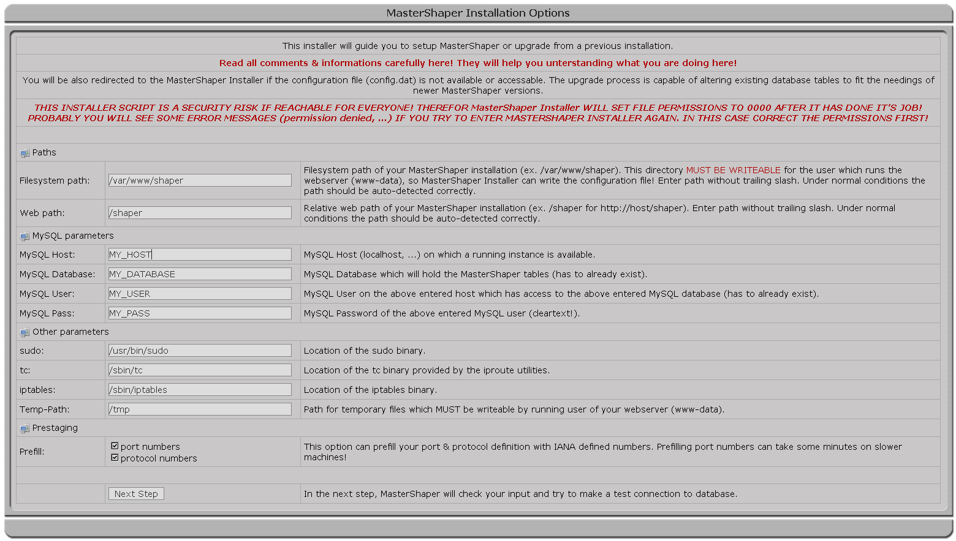

- Prepare IMQ

If you are using IMQ you need some iptables rules to get the traffic to the IMQ interfaces (EXT_DEV means your interface where you want to shape traffic):

ip link set imq0 up
ip link set imq1 up

iptables -t mangle -I PREROUTING -i ${EXT_DEV} -j IMQ --todev 0
iptables -t mangle -I POSTROUTING -o ${EXT_DEV} -j IMQ --todev 1

This rules aren't set by MasterShaper. So make sure that they are available when you start shaping.

- sudo Configuration

Mostly your web server isn't running with root privileges and so it hasn't permissions to talk with the kernel and load the ruleset (tc or iptables). To activate the rules MasterShaper uses the scripts shaper_loader.sh, a little shell script, which handles both tc- and also iptables-rules. To gain this script root privileges open the sudo config file
/etc/sudoers
and add the line
USER ALL= NOPASSWD: PATH/shaper_loader.sh
where USER is the running user of your web server (www-data, apache, ...) and PATH is the full (absolute!) file system path to your MasterShaper installation (/var/www/shaper).
A great percentage of errors happen of course incorrectly configured sudo! You can test if you have prepared sudo successfully if the following command run by USER in MasterShaper's main directory don't return anything:
sudo ./shaper_loader.sh cleanup

Don't forget that your system must meet some requirements for traffic shaping with MasterShaper. Take a look at 1.2 Requirements.

Security

The database connection parameters are stored in the configuration files
config.dat
in MasterShaper's web path directory (ex. /var/www/shaper/config.dat).

This is a critical file because it contains plain text passwords.
Access to this File must be prohibited!

The MasterShaper Installation Package includes an .htaccess file in the htdocs directory, which limits the access to the config.dat file.

Double check if this file is in its location and if your web server is configured probably to support .htaccess. If not referrer to your web server documentation how to limit access to a file in the webserver configuration (for Apache's httpd this is possible with the <FILE> directive).

Make sure, that it's not possible to download this file via web browser:

http://server/shaper/config.dat

Every time MasterShaper Installer finish it's job it tries do limit the access to the index.php file in the setup directory. If you see an error message, MasterShaper can't change file permissions, so please take care that the MasterShaper Installer is not public available from the Internet – it shows up plain text passwords!

Statistic collector tc_collector.pl

tc_collector.pl is a little Perl application which collects traffic statistics from the tc utility.

Cause there is no usable mechanism to get the current pipes distributions, it collects the total amount of bytes transferred within 10 seconds intervals and calculate a kilobits per second average from these values.

Run the tc_collector by calling:
./tc_collector.pl
It will start collecting transfer rates from the tc binary and record them into MySQL database. It will get it's configuration also from config.dat – no adaptation to the Perl t is needed.

If you call it with
tc_collector.pl -d
it will fork into background and run daemonized.

If you are expecting troubles with tc_collector.pl call the script with the parameter “-v3” and check what it's currently collecting.

Without tc_collector.pl you will get no monitoring statistics and the graphs in the web interface will not work!

Configuration

Mostly all options are plenty documented within the web interface. So this document only include short summaries.

Settings

Options

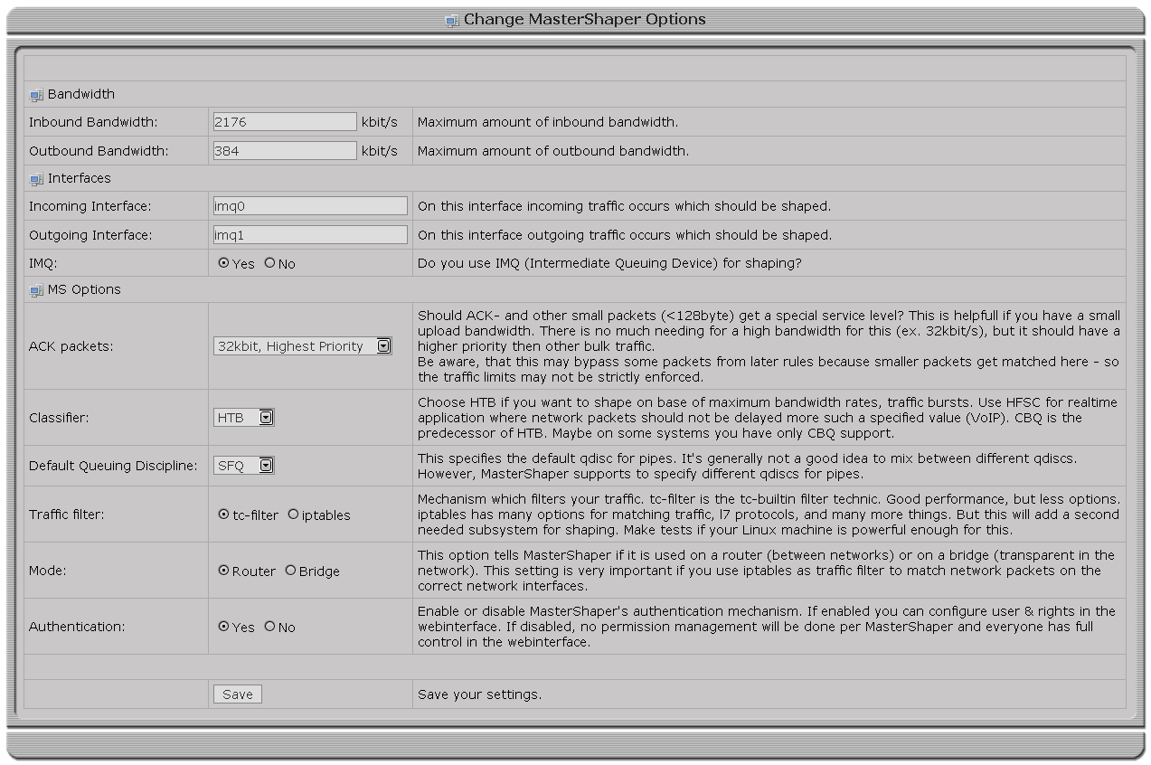
In this view you configure:

- Bandwidth

This bandwidth is essential for the init class and should be as high as the maximum speed of the specified interfaces (Ethernet, DSL, ...).

- Interfaces

Also you need to specify the incoming and outgoing interfaces on which the shaping will happen. Either configured as router or bridge you enter here the physical interfaces of your shaping device. If you are using IMQ you have to tell MasterShaper via the IMQ-Option.

- MS Options

Further more you can define a special preferred handling of ACK packets and other small packets. You have to create a service level first to handle this packets.

Configure a Classifier & Queueing Discipline that fit your needing. More informations about queuing disciplines can be found in the chapter 1.4.Classifiers & Queuing Disciplines

Choose between tc-filter & or iptables-matching. tc-filter is included in the iproute2 package and is very fast. iptables on the other side is widely used, many additional modules (ipp2p, layer-7, ...) are available and is very stable. iptables consumes a bit more additional cpu & memory for matching packets. If you don't need the features of iptables simple rely on tc-filter.

You have to tell MasterShaper if it is running on a router or bridge. This setting is very important if you are using iptables-matching because MasterShaper has to adept the iptables rules in bridge mode to match the physically interfaces (physdev) of a bridge.

New since V0.40 is an integrated User-Management. To use this feature you have to activate the authentication mechanism. It's now possible to gain users access to selective functions of MasterShaper. It's possible now to create only a user which has access to the monitoring graphs but can not change any settings. In the next versions a finer granulation of permissions will be implemented, so users can have the permissions to change pipes & filters settings within their own chains.

Users

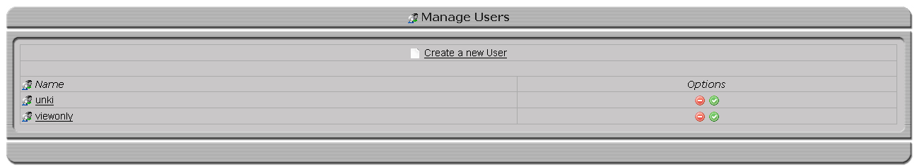
If you have a fresh MasterShaper installation the initial user is “admin” and password “changeme”.

If you have upgraded from a previous version and activated the authentication before created a new user, you will be locked out of MasterShaper because there is no user available to login. In this case delete the option “authentication” from the MySQL table shaper_settings via SQL commands or via some GUI's (phpMyAdmin, http://www.phpmyadmin.net).

Targets

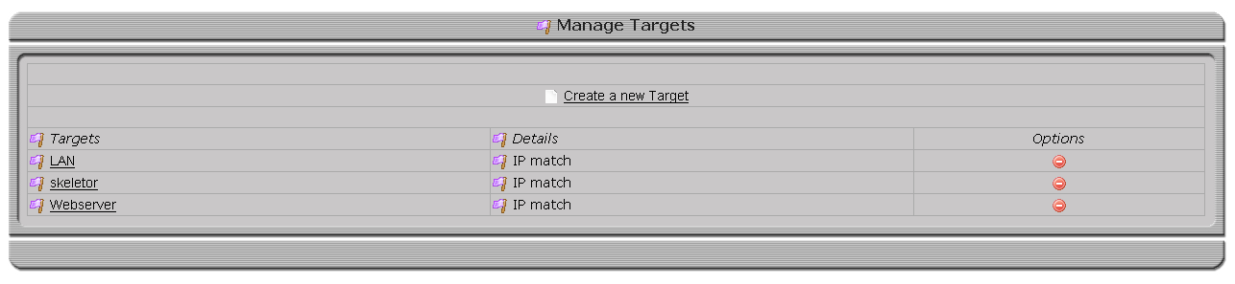

If you want to shape traffic for specific IP addresses or MAC addresses, you define them here. These definitions will then be used in the chains setup. Several target-definitions can be grouped together to a target-group for easier usage in chains.

If you have a dynamic external IP address, you don't need to specify anything here and use “any ó any” in the chain setup.

Manage

Service Levels

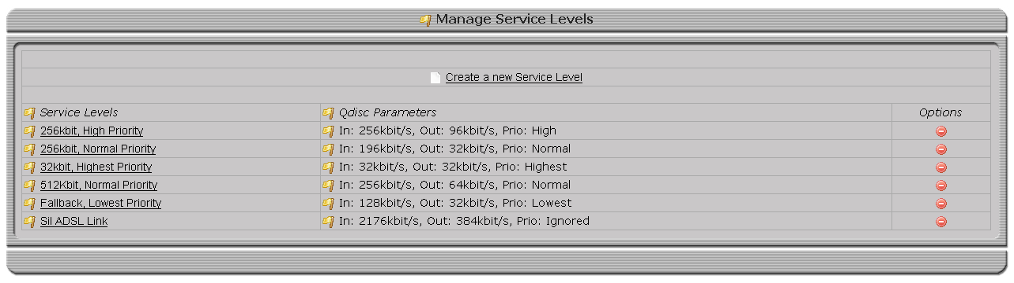
Here you specify service levels. Service Levels are used in Chains, Pipes and in Options-View. Each service level has a Classifier and a Queuing Discipline (Classifiers & Queuing Disciplines).

Filters

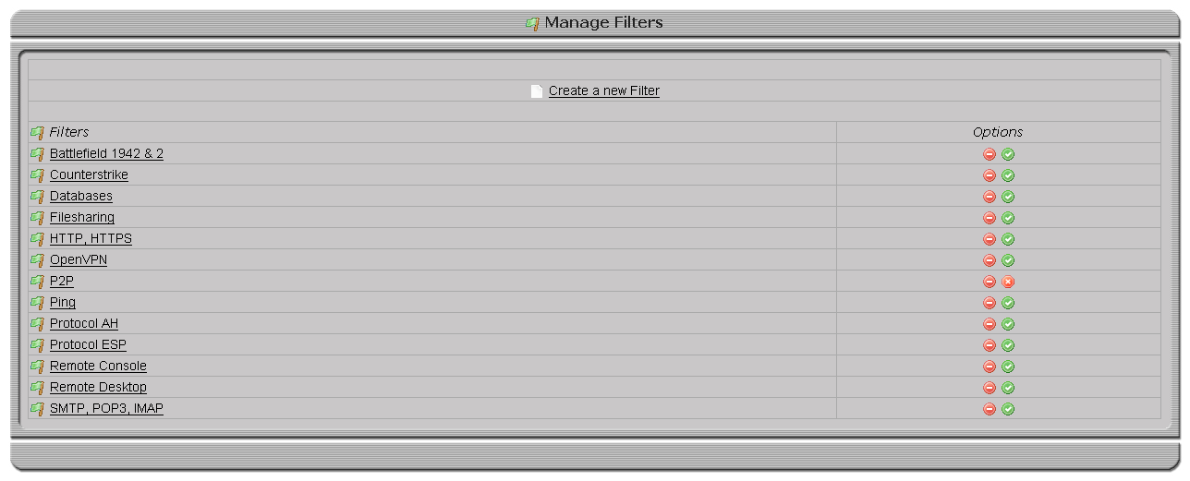
In this view you manage your filter definitions. Filters are traffic match mechanisms which classifies your traffic so it get divided up into the correct pipes.

Which sort of filters you create here is dependent on the “Traffic filter” option.

Chains

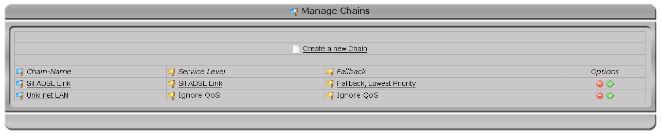
Here you manage your chain rulesets. Chains are necessary to match the traffic against targets. If the target definition match your network traffic, the network flow will be redirected into this chain so it can be matched by the following pipe definitions.

A chain needs to get defined a total amount of bandwidth and a fall-back service level. Any traffic which comes into this chain and don't get matched by any pipe definitions will fall into the fall-back service level.

Pipes

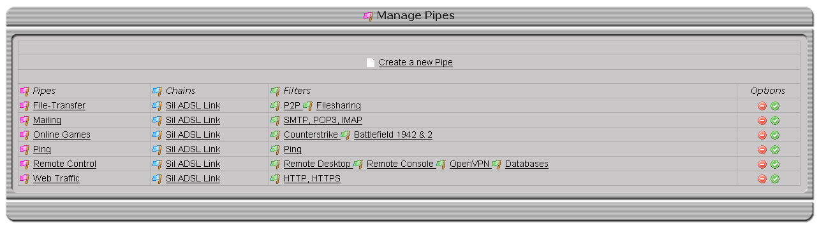

Pipes are assigned to chains and match filter-definitions against the network traffic which virtually flows through this chains. Pipes also manage how much bandwidth a service (matched by filters) can really consume.

Monitoring

Chains, Pipes and Bandwidth

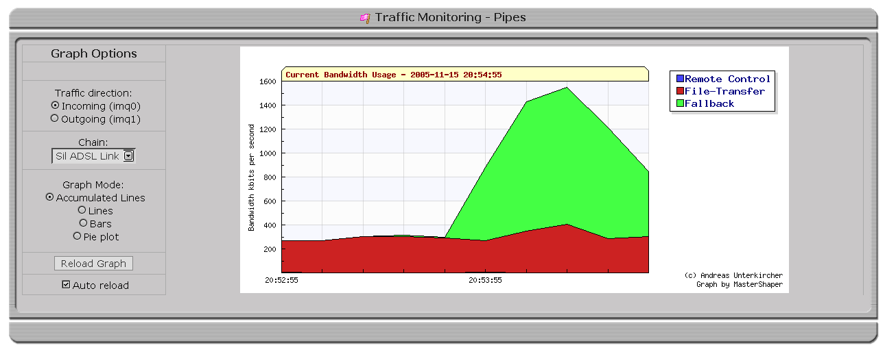
If Mastershaper's rules are loaded correctly and tc_collector.pl is active MasterShaper will draw fancy graphs:
- Chains
This view will show you the current bandwidth distribution between chains.
- Pipes
This view will show you the current bandwidth distribution of pipes. Also available is a dropdown box where you can switch between chains.
- Bandwidth
This view will present the total inbound and outbound bandwidth.

Overview

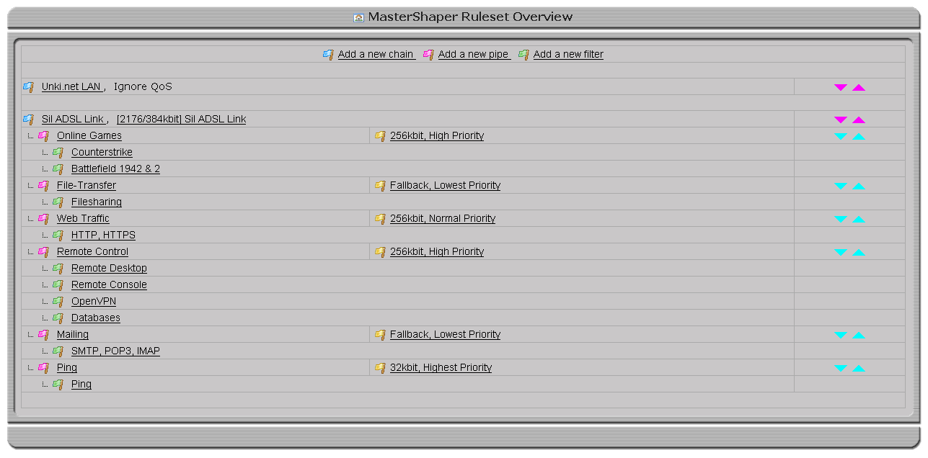
These view presents a good overview through your ruleset.

Disabled chain, pipes or filter definitions are not shown up here.
Don't forget - the first matching chain will get the traffic.

You can change the chain- & pipe-positions with the purple and turquoise arrows.

Rules

Load

This will make a bulk load of all MasterShaper rules. After every configuration change the rules have to be reloaded. From the technical view MasterShaper will first unload all rules and then load the new configuration.

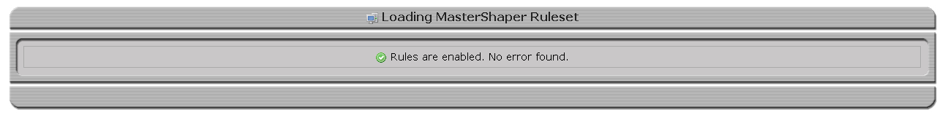
If you see a green check – everything is OK and rules are enabled. If you see a red X and some error messages then try to load the ruleset by Rules " Load (debug).

Load (debug)

This will load the ruleset rule by rule and return every error a rule makes.

Show

Show will displays you every command which would get loaded when enabling MasterShaper. This includes tc commands as well iptables commands (if iptables-matching is used).

Unload

This will disable MasterShaper's shaping functionality (if loaded).

shaper_loader.sh

With MasterShaper V0.31 a new rules-loader script was introduced. This was necessary because a script has to be able to totally clean-up any residues from MasterShaper iptables rules. This is done by the shaper_loader.sh script now.

Also it loads the tc- and iptables-ruleset so this is the only script now which needs root privileges (sudo). This will also speedup activating iptables ruleset because sudo hasn't to be accessed for every rule.

Follow the installation procedures!

Tools

Runlevel-Init-Script

If you extract the MasterShaper install archive (tar.bz2), you will find a file called mastershaper.init in the tools-directory.
It's a first version of a runlevel init script. If you want to be able, that the shaper settings will be immediate loaded after a reboot you can use this file in the runlevel scripts.
You can also use this file as an ip-up script for the pppd daemon. You have the adept the MasterShaper path with the variable PATH_TO_MS in the script. This script has to be called with root privileges.

Shaping Examples

Shaping on a Web-Server

Guidelines

- A standard LAMP-Web-Server (Linux, Apache, MySQL, PHP) with an FTP-Server.
- Connected trough DSL (PPPOE) on Ethernet with a synchronous 2Mbit/s link. IP 1.1.1.1.
- 64kbit/s should always be guaranteed to SSH (TCP/22) but can use the whole bandwidth if available. It should have a high priority.
- HTTP should have a fixed rated at 1024kbit/s but can use the whole bandwidth if available.
- FTP should have 512kbit/s available but can use the whole bandwidth if available.
- All other traffic become 256kbit/s and can't use more then 768kbit/s.

Implementation

- Go to Settings"Options and define the inbound and outbound bandwidth. Specify HTB as Queuing Discipline. Select iptables as Traffic Filter.
- Create a service level with a input & output rate definition which is equal the maximum bandwidth (2048/2048/kbit/s).
- Create a service level which has a rate of 64kbit/s and enter 2048kbit/s as ceil parameter. Set the priority to high.
- Create a service level which has a rate of 1024kbit/s and enter 2048kbit/s as ceil parameter. Set the priority to normal.
- Create a service level which has a rate of 512kbit/s and enter 2048kbit/s as ceil parameter. Set the priority to normal.
- Create a service level which has a rate of 256kbit/s and enter 768kbit/s as ceil parameter. Set the priority to low.
- Take a look on the ports-listing if you can find “http”, “https”, “ftp”, “ftp-data” and “ssh”. If not available, create new port definitions for these filters.
- Create a target for the address 1.1.1.1.
- Create a filter “Web-Traffic”. Select protocol TCP, assign the ports “http” & “https”.
- Create a filter “FTP-Traffic”. Select protocol TCP, assign the ports “ftp” & “ftp-data”. Select “Match FTP data channel”.
- Create a filter “SSH-Traffic”. Select protocol TCP, assign the port “ssh”.
- Create a new chain. The service level for this chain is the 2048kbit/s level. For fall-back use the service level with the rate of 256kbit/s. On “Affecting” choose as source “any”, as target 1.1.1.1 and select both directions.
- Create a pipe. Choose the created chain, select the filter “Web-Traffic”, the service level with the rate of 1024kbit/s and choose both directions.
- Create a pipe. Choose the created chain, select the filter “FTP-Traffic”, the service level with the rate of 512kbit/s and choose both directions.
- Create a pipe. Choose the created chain, select the filter “SSH-Traffic”, the service level with the rate of 64kbit/s and choose both directions.
- Click “Overview” and take a look on your MasterShaper configuration.
- Select Rules" Load and activate your new ruleset.

Shaping on a gateway

Guidelines

- A standard Linux-based Internet router with a mail server and pop3/imap access.
- Connected trough Ethernet with a synchronous 2Mbit/s link. IP 1.1.1.1.
- For remote control of the clients (rdp, vnc, radmin) and SSH (TCP/22) 128kbit/s should always be guaranteed. It should have a high priority.
- Mailing (SMTP, POP3, IMAP) should not block the whole bandwidth. Guaranteed 256kbit/s. A Maximum of 1024kbit/s. Lowest Priority
- HTTP & FTP should have 512kbit/s available but can use the whole bandwidth if available.
- All other traffic become 256kbit/s and can't use more then 768kbit/s.

Implementation

- Go to Settings"Options and define the inbound and outbound bandwidth. Specify HTB as Queuing Discipline.
- Create a service level with a input & output rate definition which is equal the maximum bandwidth (2048/2048/kbit/s).
- Create a service level which has a rate of 128kbit/s and enter 2048kbit/s as ceil parameter – for both directions. Set the priority to high.
- Create a service level which has a rate of 256kbit/s and enter 1024kbit/s as ceil parameter – for both directions. Set the priority to low.
- Create a service level which has a rate of 512kbit/s and enter 2048kbit/s as ceil parameter – for both directions. Set the priority to normal.
- Create a service level which has a rate of 256kbit/s and enter 768kbit/s as ceil parameter – for both directions. Set the priority to lowest.
- Take a look on the ports - listing if you can find “http”, “https”, “ftp”, “ftp-data”, “ssh”, “rdp”, “vnc”, “radmin”. If not available, create new port definitions for this filters.
- Create a target for the address 1.1.1.1.
- Create a filter “Web-Traffic”. Select protocol TCP, assign the ports “http”, “https” and “ftp”.
- Create a filter “Mail-Traffic”. Select protocol TCP, assign the ports “smtp”, “pop3” and “imap”.
- Create a filter “Remote-Control”. Select protocol TCP, assign the port “ssh”, “rdp”, “vnc” and “radmin”.
- Create a new chain. The service level for this chain is the 2048kbit/s level. For fall-back use the service level with the rate of 256kbit/s and lowest priority. On “Affecting” choose as source “any”, as target 1.1.1.1 and select both directions.
- Create a pipe. Choose the created chain, select the filter “Web-Traffic”, the service level with the rate of 512kbit/s and choose both directions.
- Create a pipe. Choose the created chain, select the filter “Mail-Traffic”, the service level with the rate of 1024kbit/s and choose both directions.
- Create a pipe. Choose the created chain, select the filter “Remote Control”, the service level with the rate of 128kbit/s and choose both directions.
- Click “Overview” and take a look on your MasterShaper configuration.
- Select Rules"Reload now and activate your new ruleset.

Shaping per department

Guidelines

- A standard Linux-based internet router which manage the internet access of 4 departments.
- The router uses IMQ in BB mode on the external interface, so you see LAN addresses on the outgoing IMQ device before NAT.
- Connected trough Ethernet with a synchronous 2Mbit/s link. IP 1.1.1.1.
- The internal networks of the departments are 172.16.1.0/26, 172.16.1.64/26, 172.16.1.128/26, 172.16.1.196/26.
- Each department has guaranteed 512kbit/s but can lend unused bandwidth from other departments.
- Departments are using VoIP from a SIP-Provider and so connecting to a SIP-server. Low Latency has to be guaranteed for this service.
- HTTP & FTP should have 128kbit/s and maximal use 256 of the bandwidth. Priority low.
- All other traffic become 64kbit/s and can't use more then 196kbit/s.

Implementation

- Go to Settings"Options and define the inbound and outbound bandwidth. Specify HFSC as Queuing Discipline.
- Create 4 targets – each one with the assigned subnets of the departments.
- Create a service level which has a rate of 512kbit/s and enter 2048kbit/s as max parameter
- Create a service level which has a rate of 256kbit/s and enter 100ms for max delay.
- Create a service level which has a rate of 128kbit/s and enter 256kbit/s as max parameter.
- Create a service level which has a rate of 64kbit/s and enter 196kbit/s as max parameter.
- Take a look at the ports - listing if you can find “http”, “https”, “ftp”, “ftp-data”. Check out, on which port-range you connect to the SIP-Provider and create a port definition for this.
- Create a filter “VoIP-Traffic”. Select protocol UDP, assign the ports “voip”.
- Create a filter “Web-Traffic”. Select protocol TCP, assign the ports “http”, “https”, “ftp” and “ftp-data”.
- Create 4 new chains. The service level for this chains is the 512kbit/s level. For fall-back use the service level with the rate of 64kbit/s. On “Affecting” choose as source “any” and as target on of your defined department targets and select both directions.
- Create 4 pipes. Choose the created department chains, select the filter “VoIP-Traffic”, the service level with the rate of 256kbit/s and choose both directions.
- Create 4 pipes. Choose the created department chains, select the filter “Web-Traffic”, the service level with the rate of 128kbit/s and choose both directions.
- Click “Overview” and take a look on your MasterShaper configuration.
- Select Rules"Reload now and activate your new ruleset.

License

MasterShaper is licensed by GNU General Public License (GPL) Version 2. All rights reserved by author Andreas Unterkircher (andreas.unterkircher@netshadow.at), http://www.mastershaper.org.

GNU GENERAL PUBLIC LICENSE
Version 2, June 1991

Copyright (C) 1989, 1991 Free Software Foundation, Inc.
51 Franklin St, Fifth Floor, Boston, MA 02110-1301 USA
Everyone is permitted to copy and distribute verbatim copies
of this license document, but changing it is not allowed.

Preamble

The licenses for most software are designed to take away your
freedom to share and change it. By contrast, the GNU General Public
License is intended to guarantee your freedom to share and change free
software--to make sure the software is free for all its users. This
General Public License applies to most of the Free Software
Foundation's software and to any other program whose authors commit to
using it. (Some other Free Software Foundation software is covered by
the GNU Library General Public License instead.) You can apply it to
your programs, too.

When we speak of free software, we are referring to freedom, not
price. Our General Public Licenses are designed to make sure that you
have the freedom to distribute copies of free software (and charge for
this service if you wish), that you receive source code or can get it
if you want it, that you can change the software or use pieces of it
in new free programs; and that you know you can do these things.

To protect your rights, we need to make restrictions that forbid
anyone to deny you these rights or to ask you to surrender the rights.
These restrictions translate to certain responsibilities for you if you
distribute copies of the software, or if you modify it.

For example, if you distribute copies of such a program, whether
gratis or for a fee, you must give the recipients all the rights that
you have. You must make sure that they, too, receive or can get the
source code. And you must show them these terms so they know their
rights.

We protect your rights with two steps: (1) copyright the software, and
(2) offer you this license which gives you legal permission to copy,
distribute and/or modify the software.

Also, for each author's protection and ours, we want to make certain
that everyone understands that there is no warranty for this free
software. If the software is modified by someone else and passed on, we
want its recipients to know that what they have is not the original, so
that any problems introduced by others will not reflect on the original
authors' reputations.

Finally, any free program is threatened constantly by software
patents. We wish to avoid the danger that redistributors of a free
program will individually obtain patent licenses, in effect making the
program proprietary. To prevent this, we have made it clear that any
patent must be licensed for everyone's free use or not licensed at all.

The precise terms and conditions for copying, distribution and
modification follow.

GNU GENERAL PUBLIC LICENSE
TERMS AND CONDITIONS FOR COPYING, DISTRIBUTION AND MODIFICATION

0. This License applies to any program or other work which contains
a notice placed by the copyright holder saying it may be distributed
under the terms of this General Public License. The "Program", below,
refers to any such program or work, and a "work based on the Program"
means either the Program or any derivative work under copyright law:
that is to say, a work containing the Program or a portion of it,
either verbatim or with modifications and/or translated into another
language. (Hereinafter, translation is included without limitation in
the term "modification".) Each licensee is addressed as "you".

Activities other than copying, distribution and modification are not
covered by this License; they are outside its scope. The act of
running the Program is not restricted, and the output from the Program
is covered only if its contents constitute a work based on the
Program (independent of having been made by running the Program).
Whether that is true depends on what the Program does.

1. You may copy and distribute verbatim copies of the Program's
source code as you receive it, in any medium, provided that you
conspicuously and appropriately publish on each copy an appropriate
copyright notice and disclaimer of warranty; keep intact all the
notices that refer to this License and to the absence of any warranty;
and give any other recipients of the Program a copy of this License
along with the Program.

You may charge a fee for the physical act of transferring a copy, and
you may at your option offer warranty protection in exchange for a fee.

2. You may modify your copy or copies of the Program or any portion
of it, thus forming a work based on the Program, and copy and
distribute such modifications or work under the terms of Section 1
above, provided that you also meet all of these conditions:

a) You must cause the modified files to carry prominent notices
stating that you changed the files and the date of any change.

b) You must cause any work that you distribute or publish, that in
whole or in part contains or is derived from the Program or any
part thereof, to be licensed as a whole at no charge to all third
parties under the terms of this License.

c) If the modified program normally reads commands interactively
when run, you must cause it, when started running for such
interactive use in the most ordinary way, to print or display an
announcement including an appropriate copyright notice and a
notice that there is no warranty (or else, saying that you provide
a warranty) and that users may redistribute the program under
these conditions, and telling the user how to view a copy of this
License. (Exception: if the Program itself is interactive but
does not normally print such an announcement, your work based on
the Program is not required to print an announcement.)

These requirements apply to the modified work as a whole. If
identifiable sections of that work are not derived from the Program,
and can be reasonably considered independent and separate works in
themselves, then this License, and its terms, do not apply to those
sections when you distribute them as separate works. But when you
distribute the same sections as part of a whole which is a work based
on the Program, the distribution of the whole must be on the terms of
this License, whose permissions for other licensees extend to the
entire whole, and thus to each and every part regardless of who wrote it.

Thus, it is not the intent of this section to claim rights or contest
your rights to work written entirely by you; rather, the intent is to
exercise the right to control the distribution of derivative or
collective works based on the Program.

In addition, mere aggregation of another work not based on the Program
with the Program (or with a work based on the Program) on a volume of
a storage or distribution medium does not bring the other work under
the scope of this License.

3. You may copy and distribute the Program (or a work based on it,
under Section 2) in object code or executable form under the terms of
Sections 1 and 2 above provided that you also do one of the following:

a) Accompany it with the complete corresponding machine-readable
source code, which must be distributed under the terms of Sections
1 and 2 above on a medium customarily used for software interchange; or,

b) Accompany it with a written offer, valid for at least three
years, to give any third party, for a charge no more than your
cost of physically performing source distribution, a complete
machine-readable copy of the corresponding source code, to be
distributed under the terms of Sections 1 and 2 above on a medium
customarily used for software interchange; or,

c) Accompany it with the information you received as to the offer
to distribute corresponding source code. (This alternative is
allowed only for noncommercial distribution and only if you
received the program in object code or executable form with such
an offer, in accord with Subsection b above.)

The source code for a work means the preferred form of the work for
making modifications to it. For an executable work, complete source
code means all the source code for all modules it contains, plus any
associated interface definition files, plus the scripts used to
control compilation and installation of the executable. However, as a
special exception, the source code distributed need not include
anything that is normally distributed (in either source or binary
form) with the major components (compiler, kernel, and so on) of the
operating system on which the executable runs, unless that component
itself accompanies the executable.

If distribution of executable or object code is made by offering
access to copy from a designated place, then offering equivalent
access to copy the source code from the same place counts as
distribution of the source code, even though third parties are not
compelled to copy the source along with the object code.

4. You may not copy, modify, sublicense, or distribute the Program
except as expressly provided under this License. Any attempt
otherwise to copy, modify, sublicense or distribute the Program is
void, and will automatically terminate your rights under this License.
However, parties who have received copies, or rights, from you under
this License will not have their licenses terminated so long as such
parties remain in full compliance.

5. You are not required to accept this License, since you have not
signed it. However, nothing else grants you permission to modify or
distribute the Program or its derivative works. These actions are
prohibited by law if you do not accept this License. Therefore, by
modifying or distributing the Program (or any work based on the
Program), you indicate your acceptance of this License to do so, and
all its terms and conditions for copying, distributing or modifying
the Program or works based on it.

6. Each time you redistribute the Program (or any work based on the
Program), the recipient automatically receives a license from the
original licensor to copy, distribute or modify the Program subject to
these terms and conditions. You may not impose any further
restrictions on the recipients' exercise of the rights granted herein.
You are not responsible for enforcing compliance by third parties to
this License.

7. If, as a consequence of a court judgment or allegation of patent
infringement or for any other reason (not limited to patent issues),
conditions are imposed on you (whether by court order, agreement or
otherwise) that contradict the conditions of this License, they do not
excuse you from the conditions of this License. If you cannot
distribute so as to satisfy simultaneously your obligations under this
License and any other pertinent obligations, then as a consequence you
may not distribute the Program at all. For example, if a patent
license would not permit royalty-free redistribution of the Program by
all those who receive copies directly or indirectly through you, then
the only way you could satisfy both it and this License would be to
refrain entirely from distribution of the Program.

If any portion of this section is held invalid or unenforceable under
any particular circumstance, the balance of the section is intended to
apply and the section as a whole is intended to apply in other
circumstances.

It is not the purpose of this section to induce you to infringe any
patents or other property right claims or to contest validity of any
such claims; this section has the sole purpose of protecting the
integrity of the free software distribution system, which is
implemented by public license practices. Many people have made
generous contributions to the wide range of software distributed
through that system in reliance on consistent application of that
system; it is up to the author/donor to decide if he or she is willing
to distribute software through any other system and a licensee cannot
impose that choice.

This section is intended to make thoroughly clear what is believed to
be a consequence of the rest of this License.

8. If the distribution and/or use of the Program is restricted in
certain countries either by patents or by copyrighted interfaces, the
original copyright holder who places the Program under this License
may add an explicit geographical distribution limitation excluding
those countries, so that distribution is permitted only in or among
countries not thus excluded. In such case, this License incorporates
the limitation as if written in the body of this License.

9. The Free Software Foundation may publish revised and/or new versions
of the General Public License from time to time. Such new versions will
be similar in spirit to the present version, but may differ in detail to
address new problems or concerns.

Each version is given a distinguishing version number. If the Program
specifies a version number of this License which applies to it and "any
later version", you have the option of following the terms and conditions
either of that version or of any later version published by the Free
Software Foundation. If the Program does not specify a version number of
this License, you may choose any version ever published by the Free Software
Foundation.

10. If you wish to incorporate parts of the Program into other free
programs whose distribution conditions are different, write to the author
to ask for permission. For software which is copyrighted by the Free
Software Foundation, write to the Free Software Foundation; we sometimes
make exceptions for this. Our decision will be guided by the two goals
of preserving the free status of all derivatives of our free software and
of promoting the sharing and reuse of software generally.

NO WARRANTY

11. BECAUSE THE PROGRAM IS LICENSED FREE OF CHARGE, THERE IS NO WARRANTY
FOR THE PROGRAM, TO THE EXTENT PERMITTED BY APPLICABLE LAW. EXCEPT WHEN
OTHERWISE STATED IN WRITING THE COPYRIGHT HOLDERS AND/OR OTHER PARTIES
PROVIDE THE PROGRAM "AS IS" WITHOUT WARRANTY OF ANY KIND, EITHER EXPRESSED
OR IMPLIED, INCLUDING, BUT NOT LIMITED TO, THE IMPLIED WARRANTIES OF
MERCHANTABILITY AND FITNESS FOR A PARTICULAR PURPOSE. THE ENTIRE RISK AS
TO THE QUALITY AND PERFORMANCE OF THE PROGRAM IS WITH YOU. SHOULD THE
PROGRAM PROVE DEFECTIVE, YOU ASSUME THE COST OF ALL NECESSARY SERVICING,
REPAIR OR CORRECTION.

12. IN NO EVENT UNLESS REQUIRED BY APPLICABLE LAW OR AGREED TO IN WRITING
WILL ANY COPYRIGHT HOLDER, OR ANY OTHER PARTY WHO MAY MODIFY AND/OR
REDISTRIBUTE THE PROGRAM AS PERMITTED ABOVE, BE LIABLE TO YOU FOR DAMAGES,
INCLUDING ANY GENERAL, SPECIAL, INCIDENTAL OR CONSEQUENTIAL DAMAGES ARISING
OUT OF THE USE OR INABILITY TO USE THE PROGRAM (INCLUDING BUT NOT LIMITED
TO LOSS OF DATA OR DATA BEING RENDERED INACCURATE OR LOSSES SUSTAINED BY
YOU OR THIRD PARTIES OR A FAILURE OF THE PROGRAM TO OPERATE WITH ANY OTHER
PROGRAMS), EVEN IF SUCH HOLDER OR OTHER PARTY HAS BEEN ADVISED OF THE
POSSIBILITY OF SUCH DAMAGES.

END OF TERMS AND CONDITIONS

How to Apply These Terms to Your New Programs

If you develop a new program, and you want it to be of the greatest
possible use to the public, the best way to achieve this is to make it
free software which everyone can redistribute and change under these terms.

To do so, attach the following notices to the program. It is safest
to attach them to the start of each source file to most effectively
convey the exclusion of warranty; and each file should have at least
the "copyright" line and a pointer to where the full notice is found.

<one line to give the program's name and a brief idea of what it does.>
Copyright (C) <year> <name of author>

This program is free software; you can redistribute it and/or modify
it under the terms of the GNU General Public License as published by
the Free Software Foundation; either version 2 of the License, or
(at your option) any later version.

This program is distributed in the hope that it will be useful,
but WITHOUT ANY WARRANTY; without even the implied warranty of
MERCHANTABILITY or FITNESS FOR A PARTICULAR PURPOSE. See the
GNU General Public License for more details.

You should have received a copy of the GNU General Public License
along with this program; if not, write to the Free Software
Foundation, Inc., 51 Franklin St, Fifth Floor, Boston, MA 02110-1301 USA

Also add information on how to contact you by electronic and paper mail.

If the program is interactive, make it output a short notice like this
when it starts in an interactive mode:

Gnomovision version 69, Copyright (C) year name of author
Gnomovision comes with ABSOLUTELY NO WARRANTY; for details type `show w'.
This is free software, and you are welcome to redistribute it
under certain conditions; type `show c' for details.

The hypothetical commands `show w' and `show c' should show the appropriate
parts of the General Public License. Of course, the commands you use may
be called something other than `show w' and `show c'; they could even be
mouse-clicks or menu items--whatever suits your program.

You should also get your employer (if you work as a programmer) or your
school, if any, to sign a "copyright disclaimer" for the program, if
necessary. Here is a sample; alter the names:

Yoyodyne, Inc., hereby disclaims all copyright interest in the program
`Gnomovision' (which makes passes at compilers) written by James Hacker.

<signature of Ty Coon>, 1 April 1989
Ty Coon, President of Vice

This General Public License does not permit incorporating your program into
proprietary programs. If your program is a subroutine library, you may
consider it more useful to permit linking proprietary applications with the
library. If this is what you want to do, use the GNU Library General
Public License instead of this License.

